V-STAR : 2021-22
SCHOLARSHIP EXAM MODEL QUESTIONS
CLASS VI TO VII

MATHEMATICS
1. The difference between the place value and face value of 3 in the numeral 6,530
is......
1) 3 2) 27 3) 33 4) 0
2. If first 100 natural numbers are divided in groups of ten each, then the
minimum number of primes are in between .............
1) 1 to 10 2) 51 to 60 3) 81 to 90 4) 91 to 100
3. The product of first five whole numbers is...........
1) 120 2) 24 3) 0 4) 10
4. In the figure, point ‘O’ is the centre of the circle. Which two points appear to
make a diameter when connected with a straight line?
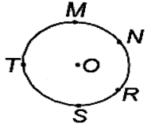
1) M and S 2) O and R 3) N and S 4) T and R
5. At breakfast, the outside temperature was 35⁰C. At lunch time, it had gone up
by 5⁰C and then at dinner time it had gone down by 2⁰C. What was the
temperature at dinner time?
1) 32⁰C 2) 39⁰C 3) 38⁰C 4) 42⁰C
6. Find the missing number in the given mathematical statement
1567.79×100+634.76×100 - ? = 110255
1) 1.1 × 100000 2) 2.2 × 10000 3) 11 × 100000 4) 0.11 × 100000
7. How many of the following letters have at least one line of symmetry?
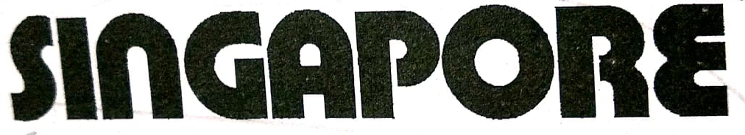
1) 5 2) 4 3) 3 4) 2
8. Find the minimum number of points at which three lines intersect
1) 1 2) 3 3) 2 4) 0
9. Find the fraction of its decimal value is 0.6 and denominator is 75.
1)$\frac{35}{75}$ 2) $\frac{45}{75}$ 3) $\frac{65}{75}$ 4) $\frac{85}{75}$
10. Arrange the following in ascending order. $\frac{6}{15}, \frac{2}{9}, \frac{4}{7}, \frac{3}{18}$ .
1) $\frac{4}{7}, \frac{2}{9}, \frac{6}{15}, \frac{3}{18}$ 2) $\frac{3}{18}, \frac{6}{15}, \frac{2}{9}, \frac{4}{7}$ 3) $\frac{3}{18}, \frac{2}{9}, \frac{6}{15}, \frac{4}{7}$ 4) $\frac{2}{9}, \frac{3}{18}, \frac{4}{7}, \frac{6}{15}$
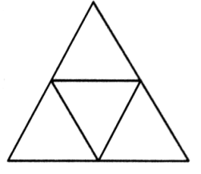
11. The net of solid is given. The shape and find the number of faces of
the solid formed when the net is folded.

- Triangular Pyramid, 4 2) Square Pyramid, 5
3) Triangular Prism, 5 4) Tetrahedron, 6
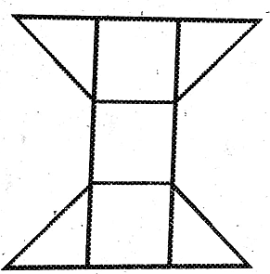
12. This figure has an area of ……….. number of triangles ( ).
1) 5 2) 7 3) 9 4) 10
13. If ▼ + ▼ + ● = 120 and ● × ● = 100, then ▼ ─ ●= .......
1) 15 2) 110 3) 45 4) 65
14. Statement - I: In Roman numerals, symbol V, L, D can be used more than
once.
Statement – II: In Roman numerals I can be subtracted only from V and X.
1) Both the statements are true
2) Both the statements are false
3) Statement-I is true but Statement-II is false
4) Statement-I is false but Statement-II is true
15. which one of the following has no line of symmetry?

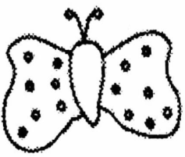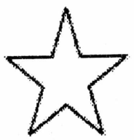
3)
4)
2)
1)

PHYSICS
16. A car is moving with a speed of 30km/h. How long will it take to cover a distance of 3854m?
1) 0.128 h 2) 1.28 h 3) 2.81 h 4) 3.63 h
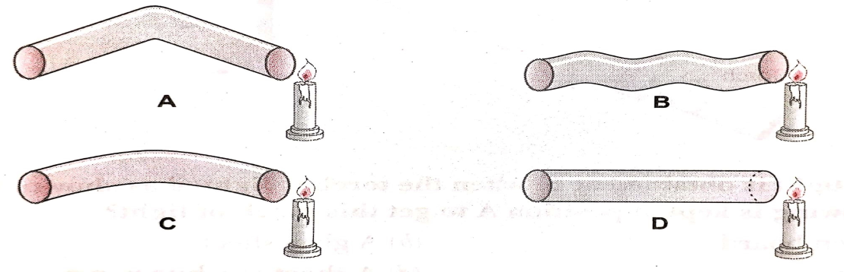
17. Four students A, B, C and D looked through pipes of different shapes to seen a
candle flame as shown in figure given below.
Who will be able to see the candle flame clearly?
1) A 2) B 3) C 4) D
18. Assertion (A): The fundamental unit which is common in CGS and SI is
second.
Reason (R): The fundamental quantity which is not common in MKS and SI is
time.
1) Both (A) and (R) are true and (R) is the correct explanation of (A)
2) Both (A) and (R) are true and (R) is not the correct explanation of (A)
3) (A) is true but (R) is false
4) (A) is false but (R) is true
19. Which of the following device does not require electric current to work?
1) Funnel 2) CD player 3) Television 4) Fan

20. In game of Tug-of war, two teams
1) Pull the rope tied with tree
2) Push the rope in opposite direction
3) Pull the rope in same direction
4) Pull the rope in opposite direction
21. In a battery two or more cells are connected in
1) series 2) Parallel
3) Positive and positive terminal 4) Random
22. Parsec is the unit to measure
1) Time 2) Distance 3) Impulse 4) Moment of inertia
23. The rate of flow of charge through the cross section is called__________
1) Voltage 2) Force 3) Current 4) Pressure
24. A glowing filament will be
1) At a low temperature 2) At a high temperature
3) At atmospheric temperature 4) at the temperature of ice
25. Study the given figure. Which phenomenon from the following is demonstrated
by the given experiment?
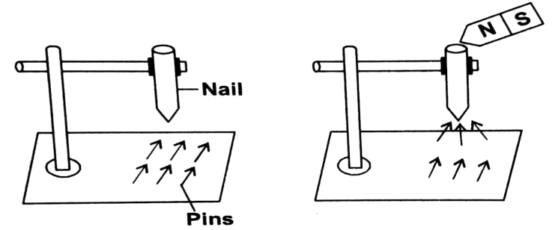
1) Pins get magnetised indirectly from the nail
2) The figure show how pins can be demagnetised
3) The nails becomes magnetised when bar magnet is touched and so
attracts the pins
4) None of these

CHEMISTRY
26. Which among the following methods would be most appropriate to separate
grains from bundles of stalks?
1) Hand picking 2) Winnowing 3) Sieving 4) Threshing
27. Study the figures given below and state the kind of changes they show.
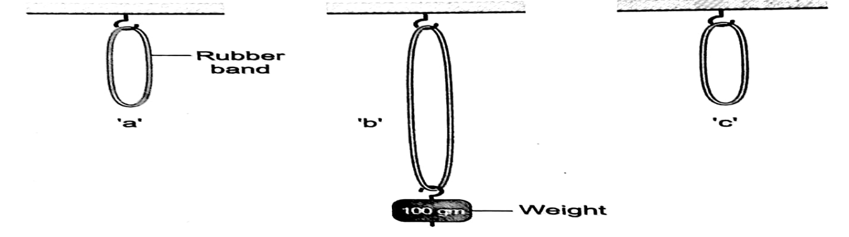
The above shows an example of a ___________ and______________
1) Reversible, Chemical 2) Reversible, Physical
3) Irreversible, Chemical 4) Irreversible, Physical
28. Percentage of CO₂ in atmosphere is ___________
1) 0.03% 2) 0.003% 3) 0.3% 4) 0.0003%
29. ‘X’ is a separation technique based on the difference in weights of the solids in a solid-solid mixture. What is ‘X’ ?
1) Sieving 2) Hand picking 3) Threshing 4) Winnowing

30. Match the entries in column –I with those in column- II
COLUMN-I COLUMN-II
a. A chalk water mixture i. A gaseous mixture
b. A glucose solution ii. A heterogeneous solid- liquid mixture
c. Carbonated water iii. A homogeneous solid-liquid mixture
d. Air iv. A gas-liquid mixture
1) a-ii, b-iii, c-iv, d-i 2)a-i, b-iv, c-ii, d-iii
3) a-ii, b-iv, c-iii, d-i 4) a-ii, b-iv, c-i, d-iii
31. Which of the following results in the formation of a new substance?
1) physical 2) chemical 3) Reversible 4) Periodic
32. If two substances interact to produce a change, they will do so
1) Under any condition
2) only if they are not in close contact with each other
3) Under any temperature 4)Under the right conditions
33. Which of the following substances contains water?
(i) Milk (ii) Blood (iii) Oil (iv) Fruits
1) only (i), (ii) and (iv) 2) only (i), (ii) and (iii)
3) only (ii), (iii) and (iv) 4) only (i), (iii) and (iv)
34. Read the two statements given below.
Statement-I:- The compressed air in a tyre exerts force large enough to lift a
heavy car.
Statement-II:- In a syringe, the plunger compresses the liquid
1) Both the statements are true
2) Both the statements are false
3) Statement-I is true but Statement-II is false
4) Statement-I is false but Statement-II is true
35. Which of the following is not attracted by a magnet?
1) Iron 2) Nickel 3) Cobalt 4) Chalk

BIOLOGY
36. The animals which depends upon other animals for their food known as
1) Herbivores 2) Carnivores 3) Omnivores 4) None of these
37. Which vitamin can easily destroyed by heat during cooking?
1) Vitamin-A 2) Vitamin- B 3) Vitamin– C 4) Vitamin-D
38. Pooja has a cup of rice, two chappatis, two vegetable curries and ghee in her
plate of meals. What is missing in her diet?
1) Fats 2) Proteins 3) Vitamins 4) Oils
39. Hemant added a few drops of a liquid on a slice of potato,upon which the area
covered by the liquid turned blue-black in colour. What coukd be the liquid?
1) Dilute iodine solution 2) Benedict’s solution
3) Pure water 4) Vegetable oil
40. How does the hump of a camel help it to survive in the desert?
1) It stores water so that the camel can remain with out water for a long time
2) It stores fat,Which provides it energy during food shortage.
3) It protects the camel against enemies
4) It balances the camel’s body while walking on sand
41. Which part of a mustard plant is edible?
1) Seeds and flowers 2) Leaves and flowers
3) Seeds and leaves 4) Stem and roots
42. The right time to cut jute plants is
1) Matured stage 2) Before flowering stage
3) Flowering stage 4)Any time after flowering
43. Which is an example of a shrub?
1) Spinach 2) Mango tree 3) Tomato plant 4) Lemon
44. Parallel venation is not found in
1) Sugarcane 2) Peepal 3) Maize 4) Wheat
45. What is the characteristic of a desert plant?
1) No leaves or very small leaves 2) Spines
3) Deep roots 4) All of these

KEY:

Q.NO | 1 | 2 | 3 | 4 | 5 | 6 | 7 | 8 | 9 | 10
ANS | 2 | 4 | 3 | 1 | 3 | 1 | 1 | 1 | 2 | 3
Q.NO | 11 | 12 | 13 | 14 | 15 | 16 | 17 | 18 | 19 | 20
ANS | 1 | 4 | 3 | 4 | 1 | 1 | 4 | 3 | 1 | 4
Q.NO | 21 | 22 | 23 | 24 | 25 | 26 | 27 | 28 | 29 | 30
ANS | 1 | 2 | 3 | 2 | 3 | 4 | 2 | 1 | 4 | 1
Q.NO | 31 | 32 | 33 | 34 | 35 | 36 | 37 | 38 | 39 | 40
ANS | 2 | 4 | 1 | 3 | 4 | 2 | 3 | 2 | 1 | 2
Q.NO | 41 | 42 | 43 | 44 | 45
ANS | 3 | 3 | 4 | 2 | 4

