V-STAR : 2021-22
SCHOLARSHIP EXAM MODEL QUESTIONS
CLASS VII TO VIII
MATHEMATICS
- The value of — 6 — [—3 + 12÷ 6 — {7 — (—4 + 20) ÷ 4}]
- —2
- —4
- 4
- —3

- By how much is $x$⁶ + 3$x$⁴y³ + y⁶ more than $x$⁶ + $x$⁴y³ – 2y⁶?
- 2$x$⁴ y³ + 3 y⁶
- 2$x$⁴ y³ - y⁶
- 2$x$⁴ y³ - 3 y⁶
- 4$x$⁴ y³ - y⁶

- In the figure if A=2 $B$and $ACD=2 DCB$, then find the measure of $DCB$+ $B.$

C

A D B

- 60°
- 90 °
- 45°
- 75°

- Assertion (A): Perimeter of rectangle is 32 cm, whose length, breadth are 10 cm and 6 cm respectively.
Reason (R): Perimeter of rectangle whose length is ‘l’ units and breadth is ‘b’ units is 2(l+b) units
- Both A and R are correct and R is the correct explanation of A.
- Both A and R are correct and R is not correct explanation of A
- A is correct, R is incorrect.
- A is incorrect, R is correct.

- The fraction $\frac{3}{8}$ is an example of _________________________
- Vulgar fraction
- Decimal fraction
- Irreducible form
- Both 1 & 3

- A terminating decimal from following is
- $\frac{3}{16}$
- $\frac{1}{15}$
- $\frac{5}{14}$
- $\frac{2}{11}$

- Given that $5^{x}$ = 1000, then 5 ^{x+2} = _____________
- 2000
- 2500
- 25000
- 40

- Statement I : The value of ($1^{1}+ 2^{2}+ 3^{3})$^{7/5} = 128
Statement II : a^{m} a^{n} = a^{m+n}
- Both statement I and Statement II are true
- Both statement I and Statement II are false
- Statement I is true, Statement II is false
- Statement I is false , Statement II is true

- The additive inverse of x² – x + 2 is __________________.
- –x²+x—2
- x² +x+2
- —x² —x+2
- —x²+ x+2

- On selling 17 balls at Rs.720, there is a loss equal at Rs 720, there is a loss equal to the cost price of 5 balls. The cost price of ball is
- Rs.45
- Rs.50
- Rs.55
- Rs.60

- The ratio between the perimeter and breadth of a rectangle is 5:1. If the area of the rectangle is 216 sq.m., what is the length of the rectangle?
- 16 cm
- 18 cm
- 24 cm
- 20 cm

- Bar diagrams are:
- 1 – dimensional
- 2 – dimensional
- 3 – dimensional
- 4 – dimensional

- Primary data called by:
- Some unpublished source
- Investigator himself
- Newspaper agency
- Some friends

- In the following figure, l⎟⎟ m, ∠ABO = 65° and ∠OCD = 25°. What is the value of x?
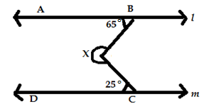
- 280°
- 270°
- 300°
- 100°

- Match the following:
From the figure. l⎟⎟ m
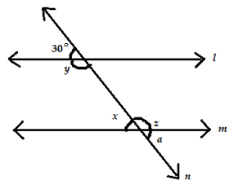
Column 1 Column 2
a. ∠x i. 30°
b. ∠y ii. 150°
c. ∠z iii. Complement & 60°
d. ∠a iv. Supplement & 30°

- a- i,iii b- ii,iv c- ii,iv d- i,iii
- a- i,ii b- iii,iv c- i,iv d- iv,iii
- a- iv,ii b- iv,iii c- i,iii d- i,iv
- a- iii,ii b- i,iv c- ii,iii d- i,ii

PHYSICS
- In a pressure cooker, the cooking is fast, because ________________________.
- more pressure is available to cook the food at 100°C
- more steam is available to cook the food at 100°C
- the boiling point of water is raised with increasing pressure inside the cooker.
- the boiling point of water is lowered with increased pressure.

- A plane mirror forms a virtual image. The distance between Rinkoo and her image produced by a plane mirror is 8 cm. How much distance should she move in order to get the distance of 4m between herself and her image?
- 2m away from the mirror
- 4m towards the mirror
- 4m away from the mirror
- 2m towards the mirror.

- One glass of water at 40°C is mixed with another glass of water at 60° C. The temperature of the mixture ‘T’ will be __________________________.
- 40°C
- 60°C
- 40° C < T°C < 60°C
- 40° C > T°C > 60°C

- Identify the phenomenon observed in the following figure.

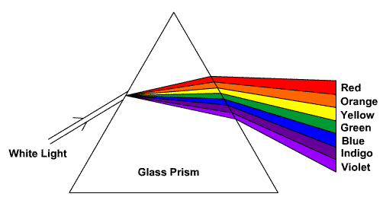
- Reflection
- Dispersion
- Deflection
- Total internal reflection

- Which of the following is matched incorrectly?
- Thermometer : Temperature
- Stop watch : Time
- Odometer : odour
- Speedometer: Speed

- Rani takes 60 minutes to travel to his school with a speed of 5 $\frac{m}{s}$. How far is her school?
- 12 km
- 60 km
- 5 km
- 18 km

- If the two terminals of a cell are connected directly with a wire, then __________________.
- no current flows
- the cell explodes
- more electric energy is stored in the cell.
- the chemicals gets used up very fast

- Observe the given graph carefully.
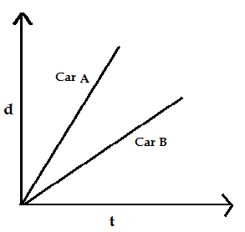
In the above graph, which car moves faster?
- Car A
- Car B
- Both travels with same speed
- Cannot be determined

- Read the given statements and select the correct options.
Statement 1: Ramu placed a coloured plastic bottle in front of the beam of a torch light. Then he didn’t observe any shadow on the screen.
Statement 2: Opaque objects do not allow the light to pass through them.
- Both statements 1 & 2 are true and statement 2 is not the correct explanation of the statement 1.
- Both statements 1 & 2 are true and statement 2 is the correct explanation of the statement 1.
- Statement 1 is true but Statement 2 is false.
- Statement 2 is true but Statement 1 is false.

- The time period of a pendulum depends upon _______________________
- the length of the pendulum
- the mass of the bob
- the material of the bob
- the size of the bob
CHEMISTRY
- The process of separating tea leaves from tea is an example of
- Evaporation
- Condensation
- Churning
- Filtration
- Dissolution of salt in water is which on of the following kinds of change?
- Chemical change
- Reversible change
- Irreversible change
- All of these

- Which of the following is a reversible change?
- Tearing of a paper
- Breaking of a stick
- Blowing air in a balloon
- Baked chapatti

- Which gas present in atmosphere allows substance to burn
- Nitrogen
- Carbon dioxide
- Oxygen
- Ozone

- Which one of the following statements is true about the potable water?
- Potable water cannot be used for irrigation
- Potable water cannot be used for dissolving chemicals
- Potable water can be used for drinking
- All of these

- Assertion and reason type:
Assertion: Hot air balloon rises up in the air
Reason: Hot air is lighter than cold air.
- Both assertion and reason are correct and reason is the correct explanation of assertion.
- Both assertion and reason are correct but reason is not the correct explanation of assertion.
- Assertion is correct but reason is incorrect.
- Assertion is incorrect but reason is correct.

- Read the given statement and select the correct option.
Statement I: Baking soda does not taste sour.
Statement II: Bases are sour in taste while acids are bitter in taste
- Both statement I & II are correct
- Both statement I & II are incorrect
- Statement I is true, statement II is false.
- Statement I is false, statement II is true.

- Study the given venn diagram carefully
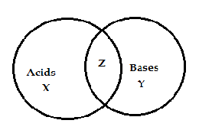
Identify X, Y and Z respectively
X Y Z
  - Do not react with metals react with litmus do not react with carbonates
  - Are sour in taste react with carbonates are soapy to touch
  - Have ${OH}^{-}$ > $H^{+}$ have ${OH}^{-}$ = $H^{+}$ have $H^{+}$ > ${OH}^{-}$
  - React with carbonates to can be identified by using Turn China rose indicator green
form CO₂ gas indicators

- Which of the following statements is/are correct about the given changes?
- Drawing copper into a wire
- Breaking of a class
- Burning of a candle
- Melting of ice.
- i and ii are chemical changes while iii and iv are physical changes
- i, ii, iv are physical changes while iii is chemical change
- i, ii, iii are physical change while iv is chemical change
- all are physical changes.

- Match the column I with column II and select the correct option.
Column I | Column II
(P) Expansion of metals on heating | (i) Neither physical nor chemical change
(Q) A stone kept in the sun light | (ii) Chemical change
(R) Burning of a candle | (iii) Combination of physical and chemical change
(S) Curdling of a milk | (iv) physical change

- P – iv, Q – iii, R – ii, S – i
- P – iii, Q – ii, R – iv, S – i
- P – i, Q – iv, R – ii, S – iii
- P – iv, Q – i, R – iii, S – ii
BIOLOGY
- In photosynthesis, CO₂ must first be converted into
- glucose
- sugars
- peptones
- galactose

- Why hot food items should not be packed in polythene bags?
- Polythene cools down the hot food
- Polythene reacts with hot food and produces cancer causing toxic products
- Polythene bag may leak due to hot food.
- all of these

- Statement A : All green plants have chlorophyll pigment
Statement B : Without Chlorophyll, Photosynthesis cannot take place.
From the above statements, Swathi concluded that the dark red color croton plants in her garden cannot prepare food on its own. But her teacher said it is not true. Why?
- Croton plants are green but do not contain Chlorophyll
- Croton plants have Chlorophyll but it is hidden by dark red colour.
- Croton plants are dark red in colour but do not have Chlorophyll
- Croton plants do not have Chlorophyll but they can prepare their own food.

- Teeth used to grind the apple in mouth are
- Incisors
- Canines
- Premolars & molars
- Molars only

- Dentine is
- Hard, protective covering on the tooth
- The soft, invisible covering present in a tooth
- The nerve that connects tooth and the brain
- The cavity which contains nerves and blood vessels in a tooth.

- Read the following statements and select the option that correctly identifies True (T) and False (F) ones.
- The number of petals and sepals in a flower is always equal.
- Roots absorb water and minerals from the soil.
- Stamen forms the inner most whorl of the flower
- Petiole is the short stalk attached to the leaf
- Calyx and Corolla form essential whorls of a plant.
- T T F T F
- F T F T F
- F T T T F
- T T F F T

- Three burning candles are covered with glass jars as shown in figures. Equal amount of air, CO₂ and O₂ are present in jars X, Y & Z respectively. Arrange the candles in decreasing order of the time for which they will continue to burn.
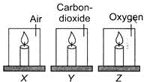
- Z, X, Y
- X, Y, Z
- X, Z, Y
- Z, Y, X

- Which of the following actions will help in reducing pollution?
- Using induction cooker instead of LPG stove for cooking
- Using unleaded petrol in cars
- Spraying pesticides on plants to kill pets
- Carrying cotton (or) jute bags for shopping instead of polythene bags.
- i & ii only
- iii & iv only
- i , ii & iii only
- iv only
44. The elbow joint is similar to this joint in its structure and movement.
- Joint between upper jaw and the rest of the head
- Joint between the bones of skull
- Joint between vertebrae and back bone.
- Knee joint

45. There are different ways of getting rid of wastes in our surroundings. Suggest the best ways of treating the following wastes:
P: Plastics Q: Medical Waste R: Agricultural wastes
- P - > Burning Q-> Recycle R-> Composting
- P - > Recycle Q-> Burning R-> Composting
- P - > Reuse Q-> Burning R-> Burning
- P - > Recycle Q-> Reuse R-> Composting

Answer Key:

Q.No | 1 | 2 | 3 | 4 | 5 | 6 | 7 | 8 | 9 | 10
Key | 1 | 1 | 1 | 1 | 4 | 1 | 3 | 1 | 1 | 4
Q.No | 11 | 12 | 13 | 14 | 15 | 16 | 17 | 18 | 19 | 20
Key | 2 | 1 | 2 | 2 | 1 | 3 | 4 | 3 | 2 | 3
Q.No | 21 | 22 | 23 | 24 | 25 | 26 | 27 | 28 | 29 | 30
Key | 3 | 4 | 1 | 2 | 1 | 4 | 2 | 3 | 3 | 3
Q.No | 31 | 32 | 33 | 34 | 35 | 36 | 37 | 38 | 39 | 40
Key | 1 | 3 | 4 | 2 | 4 | 1 | 2 | 2 | 3 | 1
Q.No | 41 | 42 | 43 | 44 | 45
Key | 2 | 4 | 4 | 4 | 2

