V-STAR : 2021-22
SCHOLARSHIP EXAM MODEL QUESTIONS
CLASS VIII TO IX
MATHEMATICS
01. If x $-$ $\frac{1}{x}$ = 2, then the value of $x^{2}$ + $\frac{1}{x^{2}}$ is ______________.
(1) 2 (2) 4 (3) 8 (4) 6
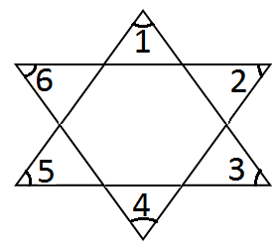
02. In the given figure;
The measure of $∠$1 +$∠2$ + $∠3$ + $∠$4 + $∠5$ + $∠6$ is _____.
(1) 270°
(2) 360°
(3) 180°
(4) 90°

03. The value of the expression $\frac{888 × 888 × 888-222 × 222 × 222}{888 × 888+ 888 × 222+ 222 × 222}$ is
(1) 666 (2) 777 (3) 66 (4) 888

04. If (4)³ $×$ (6)⁴ $×$ (10)⁵ = 2^{x} $×$ 3^{y} $×$ 5^{z}, then the value of x + y + z is __________
(1) 12 (2) 15 (3) 20 (4) 24

05. The value of x satisfying $\sqrt{x+3 }$ + $\sqrt{x-2 }$ = 5, is _______
(1) 6 (2) 7 (3) 8 (4) 9

06. The L.C.M and H.C.F of marks scored by Ajith and Amar in a maths test are 5040
and 12 respectively. If Amar’s score is 144, then Ajith score is ________.
(1) 288 (2) 132 (3) 564 (4) 420

07. The ratio of incomes of two persons is 9 : 7 and the ratio of their expenditure is
4:3. If each of them saves `200 per month, then their monthly incomes are ______.
(1) `1800, `1400 (2) `1000, `600 (3) `2700, `2100 (4) `800, `700

08. In the given figure, l || u and m || n. If $∠$ACB = 55° and $∠$AED = 30°, then x, y, z
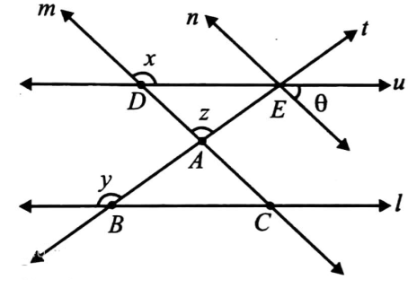
and $θ$ respectively are _____.
(1) 95°, 125°, 150°, 55°
(2) 150°, 95°, 125°, 55°
(3) 125°, 150°, 95°, 55°
(4) 55°, 95°, 150°, 125°

09. In $∆$PQR, the angle bisectors of $∠$PQR and $∠$PRQ meet at O. If $∠$QPR = 80°, then
the measure of $∠$QOR is _____.
(1) 80° (2) 130° (3) 100° (4) 90°
10. If the cost price of 6 pencils is equal to the selling price of 5 pencils, then the gain
percent is :
(1) 10$\%$ (2) 20$\%$ (3) 15$\%$ (4) 25$\%$
11. The following pie chart shows the hourly distribution of all the major activities of a
students. What is the difference in time (in hours) spends in school and in home
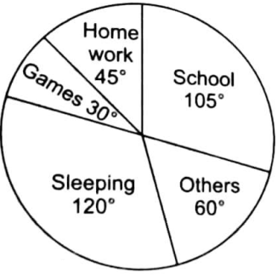
work :

(1) 2
(2) 3
(3) 5
(4) 4

12. Directions : Solve the question on the basis of information given below
a ⊕ b = a³ + b² + 1
a © b = (a - b)² + 1
a b = a³ – b² + 1
If P = (2 ⊕ 3) © (3 5), then the value of p is
(1) 225 (2) 226 (3) 246 (4) 256
13. Mr. Mohan picked a prime number between the integers 1 to 20. What is the
probability that will be a number 13.
(1) $\frac{7}{8}$ (2) $\frac{1}{20}$ (3) $\frac{1}{8}$ (4) $\frac{13}{20}$
14. Assertion (A) :$\left(\frac{2}{3} \right)$+ $\left[\left(\frac{-3}{4} \right)+\left(\frac{-9}{8} \right)\right]$=$\left[\left(\frac{2}{3} \right)+\left(\frac{-3}{4} \right)\right]$ + $\left(\frac{-9}{8} \right)$.
Reason (R) : Rational numbers are associative under addition.
(1) Both A and R are true and R is the correct explanation of A
(2) Both A and R are true but R is the not correct explanation of A
(3) A is true and R is false
(4) A is false and R is true
15. Matching :
Column – I | Column – II
(a) CSA of Cylinder | (i) lbh
(b) Volume of Cuboid | (ii) $π$r²h
(c) Volume of Cylinder | (iii) 6a²
(d) TSA of Cube | (iv) $2π$rh

(1) a - iv, b – i, c – iii, d - ii (2) a - iv, b – ii, c – iii, d - i
(3) a - iv, b – i, c – ii, d - iii (4) a - iv, b – iii, c – ii, d – i

PHYSICS
16. Two objects A and B are moving on rough surface as shown in figure. Object A
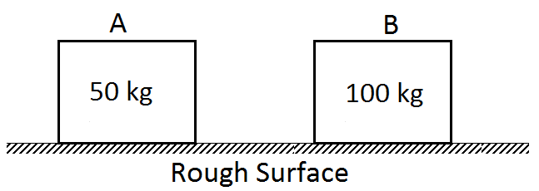
has greater velocity than B then
(1) A experiences more frictional force than B
(2) B experiences more frictional force than A
(3) Both experience same frictional force
(4) Cannot be said because data is insufficient

17. Two identical blocks of ice float in water as shown in figure, then
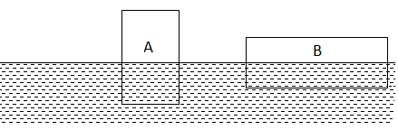

- Block – A displaces a greater volume of water since the pressure acts on a
smaller bottom area.
- Block – B displaces a greater volume of water since pressure is less on its
bottom
(3) The two blocks displaces equal volume of water since they have same weight.
(4) Block – B displaces a greater volume of water since its submerged end has a
greater area.

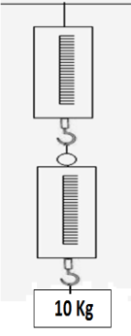
18. A block of mass 10kg is suspended through two light spring balances
as shown in figure.
(1) Both the scales will read 10 kg
(2) Both the scales will read 05 kg
(3) the upper scale will read 10 kg and lower zero
(4) The readings may be anything but their sum will be 10 kg

19. When a horse pulls a cart, the force that helps the horse to move forward
is the force exerted by
(1) The cart on the horse (2) The ground on the horse
(3) The ground on the cart (4) The horse on the ground

20. The sky would appear red instead of blue if
(1) atmospheric particles scatter blue light more that red light
(2) atmospheric particles scatter all colours equally
(3) atmospheric particles scatter red light more than the blue light
(4) The sun was much hotter.

21. Given I. Plane mirror
II. Concave mirror
III. Convex mirror
Among the above choices, virtual images can be formed by
(1) I, II and III (2) I and II (3) I and III (4) I only

22. In an electric kettle water boils in 10 minutes. It is required to boil the boiler in
15 minutes, using same power supply mains, then
(1) length of heating element should be increased
(2) length of heating element should be decreased
(3) length of heating element has no effect on heating water
(4) none of these

23. Assertion (A) : Endoscopy involves use of optical fibres to study internal organs of
human body
Reason (R) : Optical fibres are based on phenomenon of total internal
reflection of light.
- If both assertion and reason are true and reason is the correct explanation of assertion.

- If both assertion and reason are true but reason is not the correct explanation
of assertion.
(3) If assertion is true but reason is false
(4) If assertion is false but reason is true

24. Matching :
Column – I | Column – II
(a) Electric current | (i) joule
(b) Heat Energy | (ii) newton
(c) Force | (iii) pascal
(d) Pressure | (iv) ampere

(1) a - iv, b – ii, c – iii, d - i (2) a - iv, b – i, c – ii, d - iii
(3) a - ii, b – i, c – iv, d - iii (4) a - iv, b – i, c – iii, d - ii

25. Which of the following objects exerts the maximum pressure on the floor ?
(All objects have the same mass)
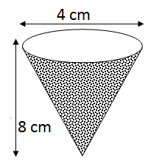
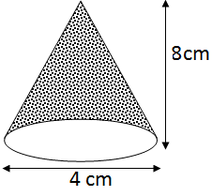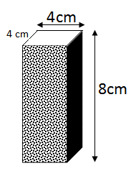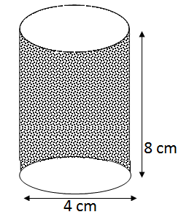

(1) (2) (3) (4)

CHEMISTRY
26. A family consumes 12 kg of LPG in 30 days. Calculate the average energy
consumed per day. If the calorific value of LPG is 50 kj/kg
(1) 10,000J/day (2) 15,000J/day (3) 20,000J/day (4) 25,000J/day
27. Vidisha placed a copper wire in silver nitrate solution as shown in the figure.
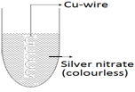

(1) The colour of solution turns blue and precipitate of solid silver was obtained
(2) Colour of solution turned green and copper wire turned blue
(3) There are no change in the colour of solution and colour of the wire
(4) Colour of the solution becomes Silver and there was no change in the colour
of the copper wire
28. Which non-metal is used in the treatment of rubber during the process of
Vulcanisation
(1) Phosphorus (2) Sulphur (3) Carbon (4) Chlorine
29. Which of the following statements is true of the given chemical reaction?
ZnO + C → Zn + CO
2Fe₂O₃ + 3C → 6Fe + 3CO₂
(1) Carbon is reduced (2) Carbon is Oxidised
(3) Metal oxide is reduced to metal (4) Metal Oxide is Oxidised
30. Ordinarily, Kerosene oil burn in air with a yellow flame. However, in stoves, it
burns with a blue flame. Which of the following statement explain the above
Observation.
(1) Complete combustion of Kerosene takes place in stoves
(2) The ignition temperature of kerosene is attained easily in stoves
(3) Stoves are made of iron and Kerosene burns with flame in the presence of iron
(4) In stoves oxygen availability is sufficient but in open place Oxygen availability
is less than required amount.
(1) i, iv (2) i, ii (3) iii, iv (4) i, ii, iv
31. Which of the following substances can be used to extinguish a fire in an oil well ?
(1) Water (2) Sand (3) CO₂ gas (4) Sodium carbonate solution
32. Metal rust when they come in contact with Oxygen of the air and forms Oxides
and thereby destroys the metal. One of the metals given below forms an oxide with
Oxygen and protects it form further rusting. The metal is ______.
(1) Iron (2) Zinc (3) Copper (4) Aluminium
33. Cotton cloths do not keep us warm because ?
(1) cotton is thinner than silk (2) cotton is cooler by nature
(3) cotton cloth do not trap air (4) Cotton is plant product

34. The process of obtaining silk fibre from Cocoons is called
(1) Reeling (2) Shearing (3) Carding (4) Yarning

35. Match the following Column – I with Column - II
Column – I (Atomic model) | Column – II (Scientist)
(i) Bohr’s model of atom | (a) J.J.Thomson
(ii) Water melon model of atom | (b) Neils Bohr
(iii) Planetory model of atom | (c) Dalton
(iv) First propose detailed theory of atom | (d) Rutherford

(1) i - a, ii – b, iii – c, iv - d (2) i - b, ii – a, iii – d, iv - c
(3) i - a, ii – c, iii – b, iv - d (4) i - c, ii – d, iii – a, iv - b

BIOLOGY
36. A Spore
(1) is an a sexual reproductive body
(2) is covered by a hard protective coat
(3) Germinates and develops into a new individual
(4) All the above
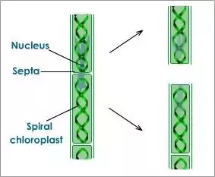
37.

The above diagram shows
(1) Division (2) Fragmentation (3) Regeneration (4) All the above

38. Find the incorrect pair
(1) Buffalo-Murrah (2) Cow-Gir (3) Cow-Sahiwal (4) Buffalo-Red Sindhi

39. Use the following information to answer the next question.
(i) and (ii) are natural causes of deforestation. The information in which
alternative completes the given statements.
(i) (ii)
a) Forest fires agriculture
b) Construction droughts
c) Forest fires drought
d) Droughts agriculture

40. Fungi differ from alga in being mostly
(1) Parasitic (2) Autotrophic (3) heterotrophic (4) Saprophytic

41. The process in which organisms do not require light and pigment and synthesize
their food utilizing energy released by oxidation of inorganic and organic
substances is
(1) Photoautotrophism (2) Heterotrophism
(3) Chemosynthesis (4) Saprotrophism

42. Mr.Jones observes insects infesting the plants on his farm. He introduces an
animal X in his farm. This animal X feed on the insects. The introduction of
animal X will lead to
(1) A decrease in crop yield (2) A decrease in the use of pesticides
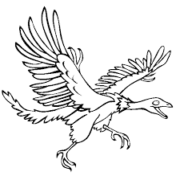
(3) An increase in water requirement (4) An increase in the use of pesticides

43.

The above picture is an example of
(1) Extinct Species (2) Endangered species
(3) Endemic Species (4) None of the above

44. A National park is
(1) An area stricktly reserved for improvement of wild life
(2) An area where grazing and cultivation are permitted
(3) A park where the whole nation can have picnics
(4) A park which can be privately owned

45. Assertion (A) : Nucleus is the controlling centre of the cell
Reason (R) : It is an autonomous cell Organelle.
- If both ‘A’ and ‘R’ are true then ‘R’ is the correct explanation of assertion.

- If both assertion and reason are true but reason is not the correct explanation
of assertion.
(3) If Assertion is true but Reason is false
(4) If Assertion is false but Reason is true

ANSWER KEY
1 | 2 | 3 | 4 | 5 | 6 | 7 | 8 | 9 | 10
4 | 2 | 1 | 4 | 1 | 4 | 1 | 3 | 2 | 2
11 | 12 | 13 | 14 | 15 | 16 | 17 | 18 | 19 | 20
4 | 2 | 3 | 1 | 3 | 2 | 3 | 1 | 2 | 3
21 | 22 | 23 | 24 | 25 | 26 | 27 | 28 | 29 | 30
1 | 2 | 1 | 3 | 3 | 3 | 1 | 2 | 2 | 1
31 | 32 | 33 | 34 | 35 | 36 | 37 | 38 | 39 | 40
3 | 2 | 3 | 1 | 2 | 4 | 2 | 4 | 3 | 4
41 | 42 | 43 | 44 | 45 | 46 | 47 | 48 | 49 | 50
4 | 2 | 1 | 1 | 1

