VELAMMAL
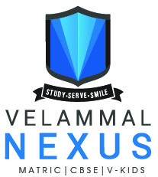
IIT & NEET ACADEMY
MEL AYANAMBAKKAM | PARUTHIPATTU ANNEXURE | ALAPAKKAM | MANGADU MOGAPPAIR WEST | MOGAPPAIR EAST

TAKE UP
V STAR
VELAMMAL SCHOLARSHIP TEST FOR ADMISSION CUM REWARD
ADMISSION TO CLASS:
AVAIL UPTO 100% SCHOLARSHIP
DATE OF EXAMINATION:

Why V STAR ?
Dual advantage for students, enabling them to excel in competitive exams and produce the best results in the school/ Board exam as per the respective Board curriculum of the school.
- Unique Pedagogy
- Stress-free Learning Environment
- Highly Qualified Faculties
- Thorough/Comprehensive Study Materials & Test Papers
- Doubt Clarification Sessions
- Integrated with Board (CBSE/Matric)
approach of Teaching

For more details
visit www.velsacademy.co.in
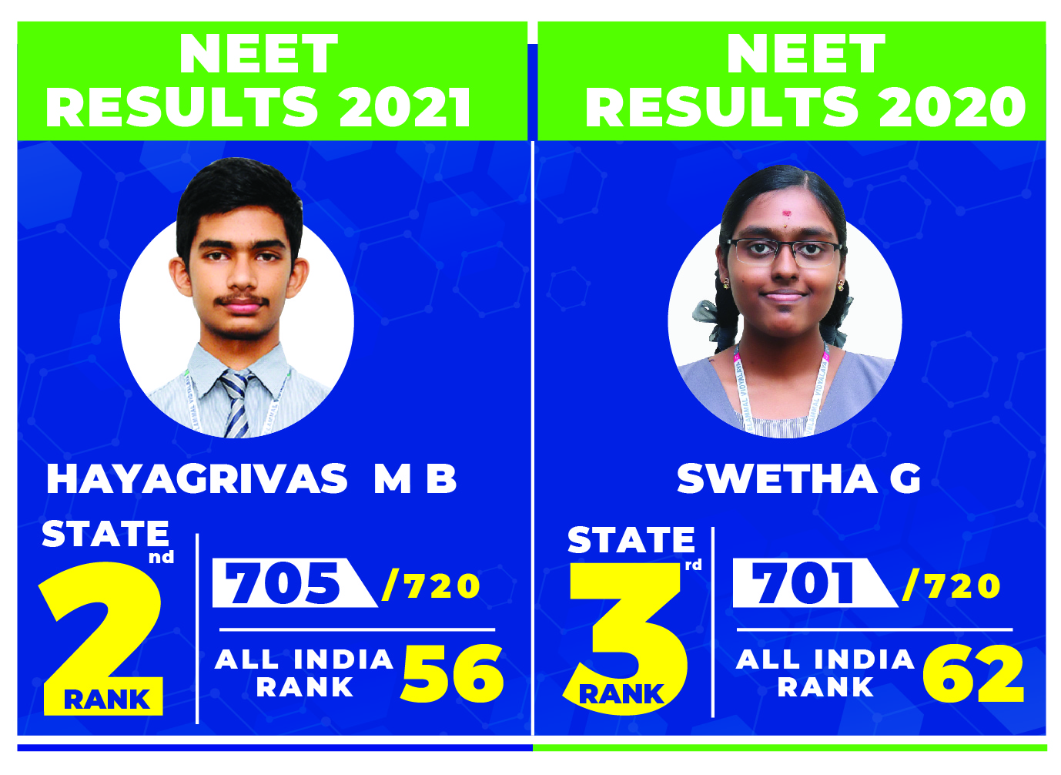

REGISTRATION FEE

Students taking up the test for the First Time

ELIGIBILITY STUDENTS
PRESENTLY STUDYING IN
CLASS V, VI, VII, VIII AND X
` 100
Students taking up the test for the Second Time
`200

NOTE – Registration fee once paid will not be refunded

MODE OF THE SCHOLARSHIP TEST - Offline
MODE OF REGISTRATION – Online / Offline
For online registration log onto www.velsacademy.co.in

HOW TO REGISTER FOR V STAR 2022
- Log onto www.velsacademy.co.in.
- Fill your details in the registration form and sign in.
- Check your email inbox that you have entered in the registration form.
- Click email verification link to verify your email address.
- Use the login credentials received through email and login.
- Verify your mobile number with the OTP SMS received.
- Select make payment option and complete the payment procedure.
EXAM TIMING AND DURATION
ADMISSION TO CLASS | EXAM DURATION | EXAM TIMING
VI, VII, VIII & IX | 2 hours | 10.00 am to 12.00 noon
XI (IIT) | 3 hours | 10.00 am to 1.00 pm
XI (NEET) | 2 hours | 10.00 am to 12.00 noon

NOTE TO ALL STUDENTS

- Maximum number of chances to take up the test is 2.
- The final percentage for IIT or NEET program in each case will remain with the management and this decision is final.
VELAMMAL NEXUS STUDENTS

ADMISSION TO CLASS | DATE OF EXAMINATION
 | DATE | DAY
VI | 23.12.2021 | Thursday
VII
VIII
IX
XI (IIT)
XI (NEET)

COURSES OFFERED

CLASS VI
FACTS 1st YEAR (Foundation for All Competitive Tests) - TARGET AMTI, SLTSE, AITSE, NLMO, NLSO, SOF, SILVER ZONE, NSTSE, INTERNATIONAL & NATIONAL OLYMPIADS.

CLASS VII
FACTS 2nd YEAR (Foundation for All Competitive Tests) - TARGET AMTI, SLTSE, AITSE, NLMO, NLSO, SOF, SILVER ZONE, NSTSE, INTERNATIONAL & NATIONAL OLYMPIADS.

CLASS VIII
FACTS 3rd YEAR (Foundation for All Competitive Tests) - TARGET AMTI, SLTSE, AITSE, NLMO, NLSO, SOF, SILVER ZONE, NSTSE, INTERNATIONAL & NATIONAL OLYMPIADS.

CLASS IX & X
(2 YEAR INTEGRATED PROGRAMME) - TARGET NTSE + NSEJS + RMO+ IIT – JEE ADVANCED AND NEET

CLASS IX TO XII
(4 YEAR INTEGRATED PROGRAMME) - TARGET NTSE + NSEJS + RMO + IIT – JEE and NEET

CLASS XI & XII
IIT (2 YEAR INTEGRATED PROGRAMME) - TARGET IIT JEE + CBSE / STATE BOARD CURRICULUM

CLASS XI & XII
NEET (2 YEAR INTEGRATED PROGRAMME) - TARGET NEET + CBSE / STATE BOARD CURRICULUM

CLASS XII APPEARING STUDENTS
(NEET CRASH COURSE) - TARGET NEET

CLASS XII PASSED OUT STUDENTS
(NEET FRESHERS / REPEATERS COURSE) - TARGET NEET

V STAR 2022-23 SCHOLARSHIP TEST SYLLABUS & PATTERN

ADMISSION TO CLASS VI

MATHS | PHYSICS | CHEMISTRY | BIOLOGY
- Place Value  - Face Value Number System (addition, subtraction, multiplication and division of natural numbers)  - Factors and Multiples  - Perimeter & Area of Regular Shapes  - Fractions and Decimals  - Shapes  - Space and Patterns  - Measurement  - Time  - Data Handling. | - Measurement  - Force  - Work and Energy  - Light and Shadow  - The Solar System | - Minerals and Rocks  - Matter  - Air | - The World of Living  - Human Brain and Sense Organs  - Our Environment  - From tasting to Digesting  Green World
ADMISSION TO CLASS VII

MATHS | PHYSICS | CHEMISTRY | BIOLOGY
- Knowing our numbers  - Natural Numbers  - Whole Numbers  - Integers  - Playing with Numbers  - Fractions & Decimals  - Basic Geometrical Ideas  - Understanding Elementary Shapes  - Perimeter and Area (Triangle, Square & Rectangle)  - Data Handling | - Motion and Measurement  - Light (Shadows and Reflection)  - Simple Machines  - Sources of Energy | - Air  - Water  - Sorting of materials into groups  - Changes around us  - Separation of Substances | - Food where does it come from  - Components of Food  - Fibre to Fabric  - Body Movements

ADMISSION TO CLASS VIII

MATHS | PHYSICS | CHEMISTRY | BIOLOGY
- Number System (Up To Rational Numbers Operations)  - Geometry (Angles, Transversal & Triangles and its Properties)  - Algebra (Like, Unlike Terms, Operations & Substitutions)  - Perimeter and Area (Triangle, Parallelogram, Rectangle, Square, Rhombus & Circle)  - Data Handling  - Comparing Quantities  - Exponents and Powers | - Electricity and Circuit  - Motion and Time  - Heat  - Light | - Changes around us  - Air around us  - Acids  - Bases and Salts  - Water | - Nutrition in Plants & Animals  - Fibre to Fabric  - Body Movements  - Garbage in Garbage out  - Weather  - Climate and Adaptation of Animals to Climate.
ADMISSION TO CLASS IX

MATHS | PHYSICS | CHEMISTRY | BIOLOGY
- Rational Numbers,  - Algebra (Basic Identities)  - Geometry (lines and angles, triangles, quadrilaterals)  - Mensuration (Plane mensuration)  - Data Handling  - Exponents and Powers and Comparing quantities (ratio, proportion, percentages, profit and loss, simple interest, compound interest)  - Simple equations | - Kinematics  - Laws Of Motion  - Friction  - Work  - Energy  - Ray optics  - Heat  - Electricity | - Atomic Structure  - Physical & Chemical changes  - Metals & Non metals  - Coal & Petroleum  - Combustion & Fuels  - Acids & Bases | - Cell - The fundamental unit of life  - Tissues  - Diversity in living organisms (Plant and Animal kingdom)  - Improvement in Food resources  - Nutrition and Health
ADMISSION TO CLASS XI IIT

MATHS | PHYSICS | CHEMISTRY
- Number theory  - 2D-coordinate system  - Geometry (Triangle, Lines, Circle and Quadrilateral)  - Probability (up to addition theorem)  - Permutation & Combination  - Heights and Distances  - Statistics  - Trigonometric Ratios  - Mensuration  - Basic Algebra | - Kinematics  - Laws Of Motion  - Friction  - Work-Power-Energy  - Gravitation  - Ray Optics  - Fluid Statics  - Sound  - Heat, Electricity & Magnetic effects of electric current | - Chemical reactions and equations  - Metals and Non-Metals  - Acids, Bases and salts  - Atomic Structure  - Periodic classification of elements  - Basics of mole concept  - Carbon and its compounds
ADMISSION TO CLASS XI NEET

MATHS | PHYSICS | CHEMISTRY | BIOLOGY
- Real numbers  - Polynomials  - Linear equations  - Geometry  - Mensuration  - Statistics  - Probability  - Coordinate Geometry  - Progressions  - Trigonometry | - Kinematics  - Newton’s Laws of Motion  - Work-Power and Energy  - Gravitation  - Electricity | - Chemical reactions and equations  - Acids, Bases and Salts  - Metals and Non-Metals  - Atomic Structure  - Periodic classification of elements  - Basics of mole concept  - Carbon and its compounds | - Life processes  - Reproduction in organisms (Plants, Animals and Human)  - Heredity and Evolution  - Bio-geo chemical cycle  - Diversity in living organisms  - Eco systems

Breaking the Record yet again in 2021 !

27
NTSE
SCHOLARS
220
SELECTIONS THROUGH
NEET 2021
55
6
KVPY
SELECTIONS

IIT/NIT
LEADING UNIVERSITIES

STATE
2nd
RANK IN
62
INO
SELECTIONS

EET 2021
N

Velammal Matric. Hr. Sec. School
“Velammal Gardens”, T.S. Krishna Nagar, Mugappair East, Chennai - 600037.
+91 44 2656 0063 / 2656 1166 | Email: info@velammalmain.com
Velammal Vidyalaya
“Velammal Avenue”, Mel Ayanambakkam, Chennai - 600 095.
+91 80561 35353 / 80560 11666 | Email: info@velammalvidyalaya.in
“Velammal Avenue”, Koladi Road, Paruthipattu, Avadi, Chennai - 600 071.
+91 95660 21992 / 95660 21669 | Email: info@velammalvidyalayaavadi.in
“Velammal Avenue”, Seemathamman Nagar, Alapakkam, Maduravoyal, Chennai - 600 095.
+91 75500 74003 / 7550024234 | Email: info.alapakkam@velammalnexus.com
“Velammal Avenue”(Annexure), Mel Ayanambakkam, Chennai - 600 095.
+91 99400 25554 / 99400 12184 | Email: info.annex@velammalvidyalaya.in
“Pearl Palace”, Block No.7, Mugappair West, Chennai – 600 037.
+91 44 2653 2578 / 2653 3312 | Email: info@velammalwest.com
FOR FURTHER DETAILS CALL
6300 914 869/7358390410
www.velsacademy.co.in

